Importing Moodle Grades into Cyberbear

In order to import grades from Moodle into Cyberbear, you will need to export your Moodle gradebook as an Excel file and then upload the file to Cyberbear. There are some adjustments that need to be made to the spreadsheet before the upload to Cyberbear, however. If you have a class of less than 30 students, you may find it is quicker to just manually enter grades into Cyberbear.

Export the Moodle Gradebook Spreadsheet:

- Select Grades under the Administration menu.
- Because you need to enter letters grades in Cyberbear, you need to check a few things in Moodle first. Once you are in the gradebook, select the “Letters” tab. Check that the default letter grade scale listed matches your grading scale. If you need to make adjustments, click the “Edit” tab, make any necessary changes and then click “Save changes.”
- Next select the “Export” tab and click the “Excel spreadsheet” tab. You can keep all the grade items selected (or if you prefer you can unselect all items and only keep Course Total selected since that is the only one needed).
- Next click the “Export format options” menu and change the Grade export display type to “Letter.”
- Click the “Export” button and it will download an Excel file of your gradebook.
- Change the column heading for Institution to Term Code and enter the appropriate term code for all students. (You can use copy but make sure it does not change the last digit in the number.) The term code is the current year followed by the semester code using 70 for Fall, 30 for Spring, and 50 for Summer. (i.e., Fall 2016 is 201670, Spring 2017 is 201730, and Summer 2017 is 201750, etc.)
- Change the column heading for Department to CRN and enter the CRN of your course for all students. (You can use copy but make sure it does not change the last digit in the number.)
- Delete the “Last downloaded” column and add a column heading for Last Attend Date. If you have any grades of F, I, NC, RF, or NCR you will need to enter a last date attended. Enter the date in the format MM/DD/YYYY (for example, 10/18/2016). Then save the spreadsheet to your desktop. At this point you can go to Cyberbear to upload your spreadsheet and continue with the following instructions.

Upload Grades to Cyberbear:

- Login to Cyberbear and select “Cyberbear for Faculty and Advisors.” Click the button “I understand the FERPA Warning” then choose “Faculty Grade Entry” and click the “Final Grades” tab.
- Select the course that you want to enter grades into by clicking anywhere on the row of the course.
- Click the Tools drop-down menu in the top right corner and choose “Import.”
- Click the “Choose File” button and select your saved spreadsheet and click “Next.”
- Make sure that the checkbox for “My spreadsheet has headers” is checked and click “Next.”
- The following fields need to be checked: Term Code, CRN, Student ID, Final Grade, and Last Attend Date. If any of those are not checked, find the column of your spreadsheet preview below and find the matching field name in the drop-down menu above that column [Figure 1]. You will see “Ignore” in the drop-down menu at first for columns that don’t match up. For the ID Number column, the matching field will be Student ID. For the Course Total column the matching field will be Final Grade. You may need to match the Last Attend Date column to the field even though the names match. Once you have matched (or mapped) these fields, you should see the 5 required items checked, then click “Next.” If “Next” is grayed out, you still need to match a column with a field.

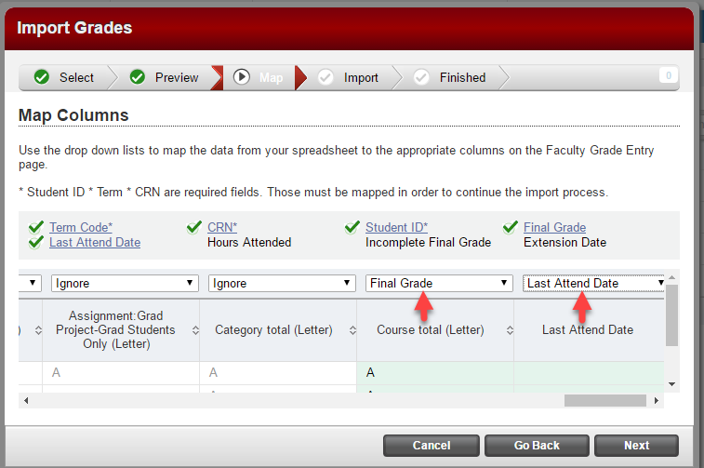
Figure 1: Mapping columns

- You will get a preview of the import and it will indicate how many records will be imported and whether there are any errors. If there are no errors, click “Import.” If there are errors, you can click the link to “Download the validation report” to troubleshoot. You may need to fix something in your spreadsheet and Go Back or Cancel to re-upload the revised file. If you had grades of F, I, NC, RF, or NCR you may get some errors. You can still finish the import and then just manually adjust those grades that didn’t import.
- Once you have imported, you will get a message of the number of “records imported and saved successfully.” Then click “Finished.”
- Check the list of grades to make sure all grades are entered. If you have any missing grades you can add those manually and click “Save.”
- Once you are finished you can log out. If you need to change any grades you can do so manually and be sure to click “Save” again. If you need to redo all the grades, you will have to manually remove them and re-enter them either manually or do a new import with an updated spreadsheet.

