How to Export Grades from Moodle

Your Moodle gradebook can be exported to Excel or other spreadsheet programs to keep an external file of your gradebook for archiving or printing. Follow these steps to export your gradebook:

Follow these steps:
- Go to the Gradebook in your Moodle course shell (gear icon > Gradebook setup or Course Dashboard > Gradebook) and select the Export tab at the top.
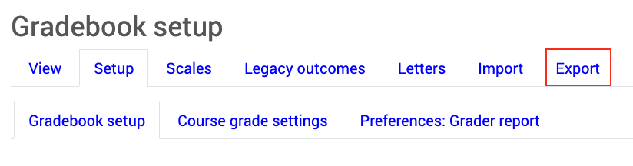
- Just below the tabs, choose an export format (usually Excel spreadsheet).
- All grade items will be included unless you uncheck items.
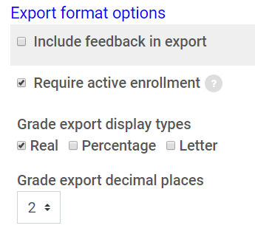
- Click the Export format options and indicate the following:
  - Include feedback in export: Check the box if you want your feedback for assignments included.
  - Grade export display type: Choose the display type you used in your gradebook (you can export several versions if you wish).
    - Real shows point values
    - Percent shows grade percentage
    - Letter shows letter grades
  - Grade export decimal points: Choose the number of decimal places you want to be included.
- Once you have made your option selections, click "Export" and a dialog box will open to let you save or open the Excel file.

If you need assistance with using the Gradebook Export feature, please contact the UM Instructional Design Team at UMOnlineIDs@umontana.edu. Support is available Monday through Friday, 8:00 a.m. to 5:00 p.m. (Mountain Time).

