How to Create a Backup of Your Moodle Course
When you create a backup of a course, you’re essentially creating a file copy of your online content that you can store for future use/reference. Backup files can be restored into a blank Moodle shell. Here are the steps:
- Select Backup from the Admin menu.
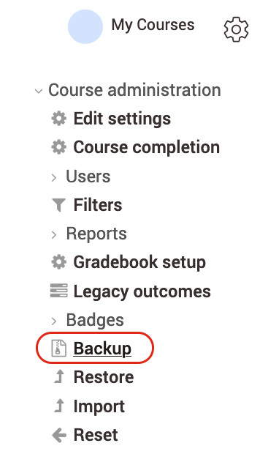
- Uncheck anything in Initial Settings that you don’t need backed up (usually all the default selections are just fine), and click “Next.” If you don’t have anything to uncheck and want everything included in the backup, you can click “Jump to final step.”
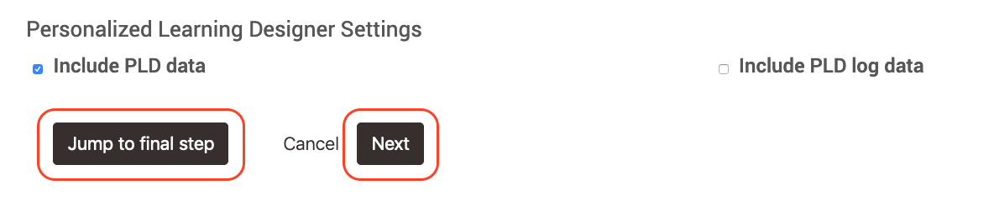
- If you choose “Next” in the previous step, uncheck any items in Schema Settings that you don’t need backed up. You can usually just leave most of the items checked, but any old, inaccessible Forums should be unchecked and recreated as accessible Advanced Forums when you restore the course. When you’re done, click “Next.”
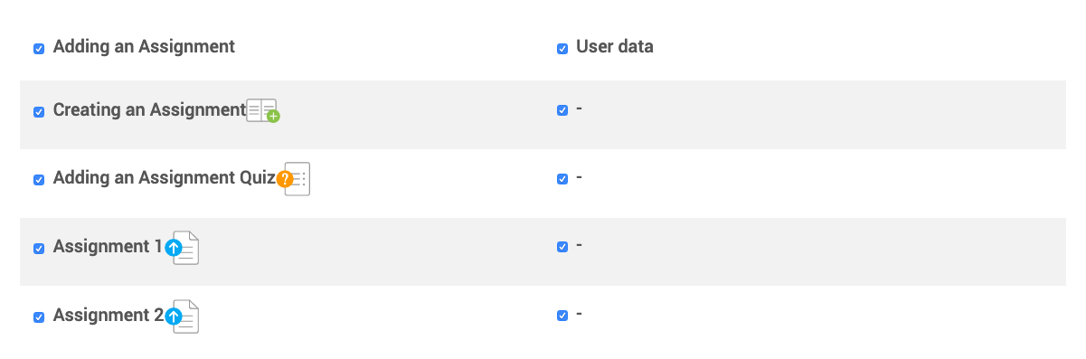
- The next screen is to review and confirm your selections. If you need to change anything use the “Previous” button to go back to make adjustments. Otherwise, just click “Perform backup.”

- Depending on the amount of content, this may take a few minutes to process. You will see a message highlighted in green “The backup file was successfully created” when the backup is completed. You might see a message regarding external file references, which is just a reminder. Click “Continue” to finish.
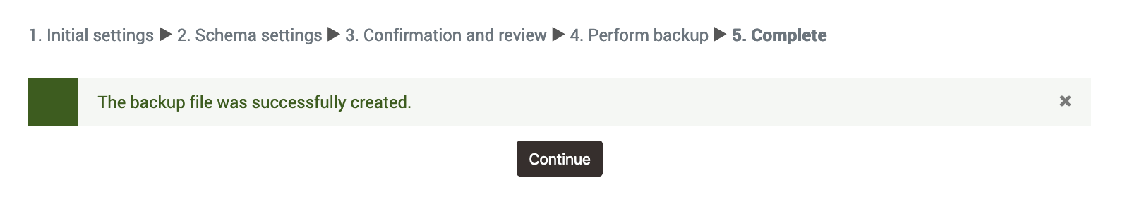
- You will then see your backup file listed in the Course Backup Area. Click the “Download” link of the most recent backup file to download it to your computer’s hard drive.
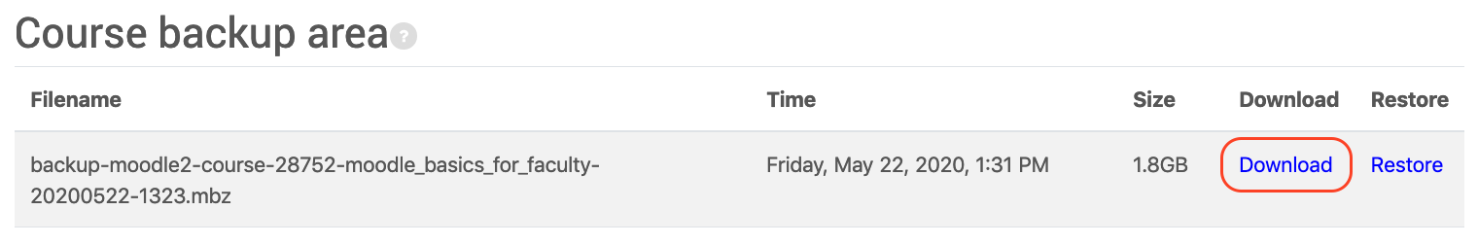
- You should delete older backup files as they are not needed. To do this click “Manage backup files.” You can then select any unnecessary backup files, keeping only the most recent. You might want to select the “Display File Details” button (see below) to see the last modified date. You can also select the most recent backup file and download it to your computer to have a backup file of your own. Click “Save changes” when you are finished. To exit the manage files screen, click the large title of your course or the course name link in the breadcrumb trail.
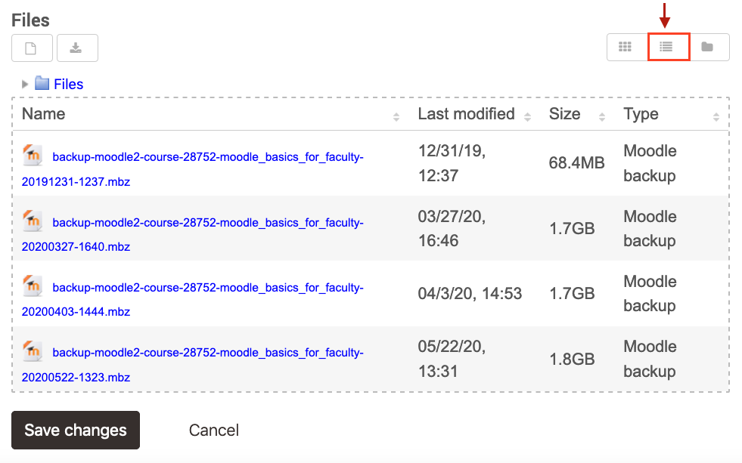
If you need assistance with using the Backup feature, please contact the UM IT Help Desk at 243-4357 or fill out the Moodle Help request form. The Help Desk is open Monday through Friday, 8:00 a.m. to 5:00 p.m. (Mountain Time).

