How to Restore a Moodle Course from a Backup File

Restore is used to copy content from one course to another so it works much the same as Import. However, Restore will allow you to copy content from the backup file of your course rather than from an active course. Therefore, you can use the backup copy that is saved to your computer at any time and do not need to keep your course active.

Here are the steps:

- First, you will need the backup file of the course you want to restore. To backup a course, go to the course and then select Backup under the Administration block. This page lists the Initial Settings, which are the default selections and don’t need to be changed, so click “Next.” The next page is the Schema Settings. You can uncheck any items you don’t need on this page. It is important that you uncheck SCORM files and Web Conferences if they appear on your list of content. If you try to bring these two items over, it will cause the restore process to fail. All other content items can be transferred, however. Once you have unchecked SCORM, Web Conferences and any other content you do not want transferred, select the “Next” buttons and then “Perform Backup” button until the prompt indicates your backup was successful. Click “Continue” and this will take you to the Backup Area. Click the “Download” link of the most recent backup file to download it to your computer’s hard drive. You can delete old backup files by clicking “Manage backup files,” clicking on the name of the file, and clicking the “Delete” button. (You may want to change the view of the files by selecting the detailed view icon in the upper right of the window to determine the dates of the files.) Be sure to click the “Save changes” button when you’re done.
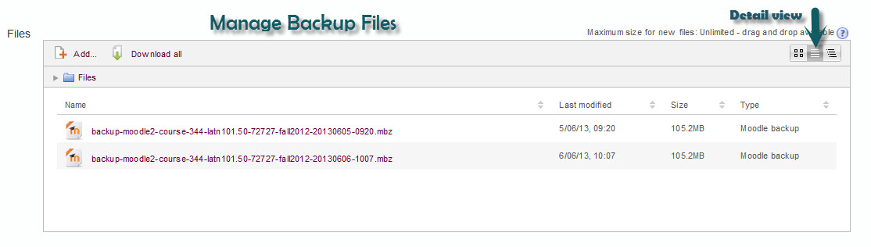
- Go to the course that you want to restore into—this is your target course. If you have content in that target course that you want to keep, it is a good idea to back it up before you perform the restore. Save the backup file to your computer by going to “Manage my backup files” and selecting the Download link, as described in Step 1 above.
- You can perform the Restore from the Manage Backup Files if you are still in that screen after backing up the target course. If you are back on the front page of your target course, go to the Administration block and select Restore. (Again, be sure you are in your target course.)

- Drag and drop your backup file of the course you want to bring into this target course. Be patient as it may take a few minutes—there is a progress bar to let you know the status of the file upload. Do not repeatedly drag and drop the backup file; eventually, it will appear. Once the backup file appears in the file window, click Restore.
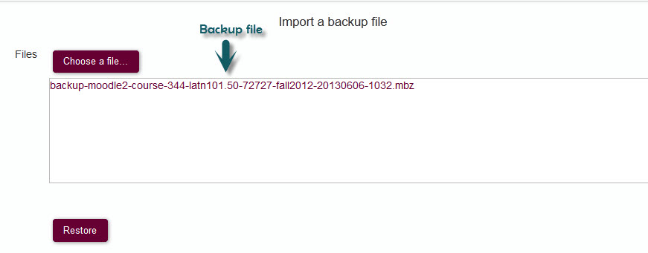
- Scroll down and click “Continue” on the Confirm page (Step 1 on the progression steps at the top of the screen).
- The next page is the Destination page (Step 2). Select the type of restore you want to perform: You will need to scroll down to the section heading Restore into this course. When you choose to restore into the current course you will need to indicate whether you want to either: 1) Merge the backup into this course, which will keep any existing content in the target course; or 2) Delete the contents of this course and then restore, which will replace existing content with the restored content. Make your selection then click “Continue.”
- On the next screen (Settings), uncheck any items you do not want to restore (generally, you can just accept the default selections) and then click “Next.”
- On the next screen (Schema Settings), again, all items are selected to restore by default. Uncheck any items you do not want to restore. You can uncheck individual items or entire topics. You should not change anything else in the course configurations, including the name or short name. Once you have the items you want selected, click “Next.”
- On the Review screen, review the items selected. If you want to make any changes you can click “Previous” at the bottom of the screen to make adjustments. When you are satisfied with the checked items, confirm by clicking “Perform restore.”
- Depending on the amount of content to import, this may take a few minutes to process. You will see a message indicating when the restore is complete. Click “Continue” and you will be taken to the front page of the newly restored course.
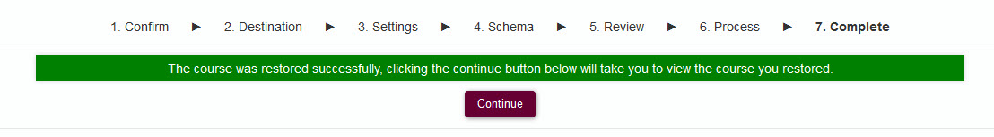

If you need assistance with using this feature, please contact UMOnline Help Desk at 243-4999 or umonline-help@umontana.edu. The Help Desk is open Monday through Friday, 8:00 a.m. to 5:00 p.m.

