Moodle 2: How to Import Content into a Course

To transfer content from Moodle 1 to Moodle 2, you will need to use the course backup file and the Restore tool. Import cannot be used to transfer course content from a Moodle 1 course into a Moodle 2 course. For instructions on using Restore, see the tip sheet titled “How to Restore Content into a Course” under Moodle 2 Resources for Faculty. You may also contact the UMOnline Help Desk for assistance at 243-4999 or umonline-help@umontana.edu. If your Moodle 1 course was in Page Format, please contact the Help Desk for assistance since this format will require an alternate method to transfer content.
- Before importing content, you should first backup the course you want to import. For a course in Moodle 1, select Backup from the Administration block. For a course in Moodle 2 select Backup in the Settings block. You will be presented with a list items to backup. It is assumed you want to backup all your content, but you can uncheck anything you don’t need. Select the Continue or Next buttons until you see a message that the backup process is completed.
- Go to the course that you want to import into. If you have content in that course, it is a good idea to back it up before you perform the import.
- In the Settings block, select Import.
- Select course that you want to import from the list of your available courses or search for the course and select; then click “Continue.”
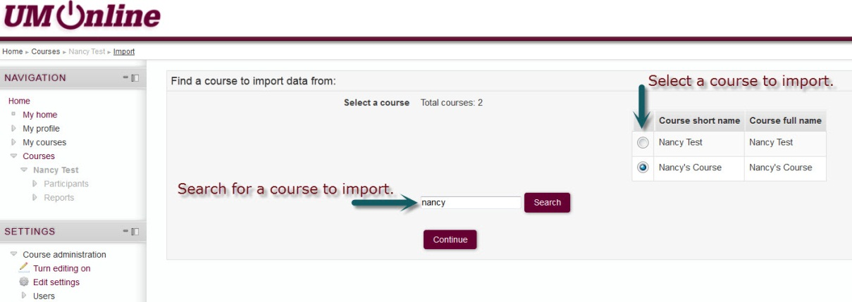
- On the next screen (Initial Settings), all Backup Settings are selected to import by default; uncheck any items you do not want to import (generally, you can just accept the default selections). Unless you are using the Personalized Learning Designer you do not need to worry about those settings. Then click “Next.”
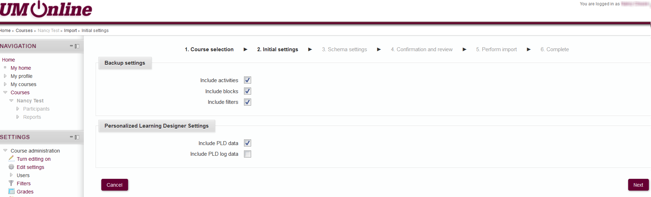

- On the next screen (Schema Settings), again, all items are selected to import by default. Uncheck any items you do not want to import. You can uncheck individual items or entire topics. Once you have the items you want selected, click “Next.”
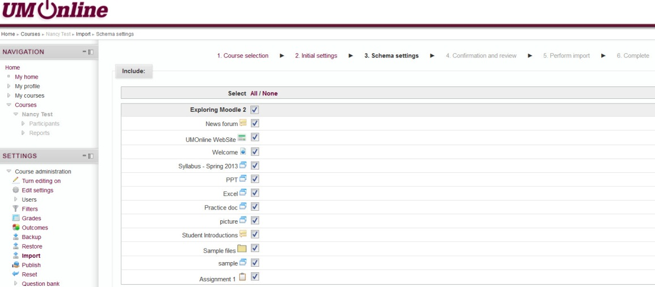

- Review the items selected. If you want to make any changes you can click “Previous” at the bottom of the screen to make adjustments. When you are satisfied with the checked items, confirm by clicking “Perform import.”
- Depending on the amount of content to import, this may take a few minutes to process. You will see a message indicating when the import is complete.

If you need assistance with using this feature, please contact UMOnline Help Desk at 243-4999 or umonline-help@umontana.edu.

