How to Import Content into a Moodle Course

Import is used when you want to copy content from one course to another and both courses are currently available to you in Moodle.

Here are the steps:

- Before importing content, you should first backup the course you want to import from. If you have content in the course you’re importing to, you should back that up as well. To backup a course, select Backup from the Course administration block if you are using the Clean theme in your course. If you are using the Snap theme layout, the Course administration menu is accessed by clicking the “gear” Admin icon in the upper right corner of your Moodle shell next to your Profile.

- You will be presented with a list of items to backup. It is assumed you want to backup all your content, but you can uncheck anything you don’t need. Select the “Jump to final step” or “Next” buttons until you see a message that the backup process is complete. Detailed instructions on backing up courses in Moodle can be found at the Faculty & Staff page under Moodle Tip Sheets (How to Backup a Course in Moodle).
- When you’re done creating backups and you’re ready to import, go to the course that you want to import content into and select Import from the Course Administration block if you are using the Clean theme. If you are using the Snap theme layout, click the “gear” Admin icon to open the Administration menu and select Import.
- Select the course that you want to import from in the list of your available courses or search for the course and select it, then click “Continue.”
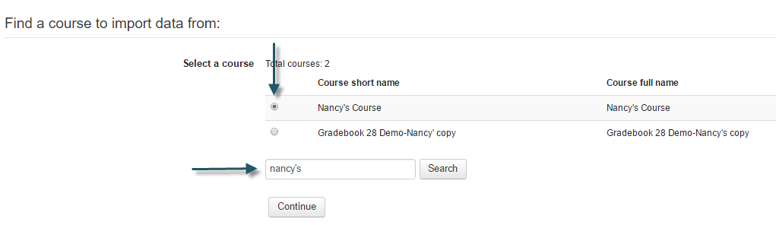
- On the next screen (Initial Settings), all items are selected to import by default. Uncheck any items you do not want to import. Generally, you can just accept the default selections since you will choose specific items in the next step. Unless you are using the Personalized Learning Designer, you do not need to select that settings. Then click “Next.” If you plan to import all the content, you can select “Jump to final step.”
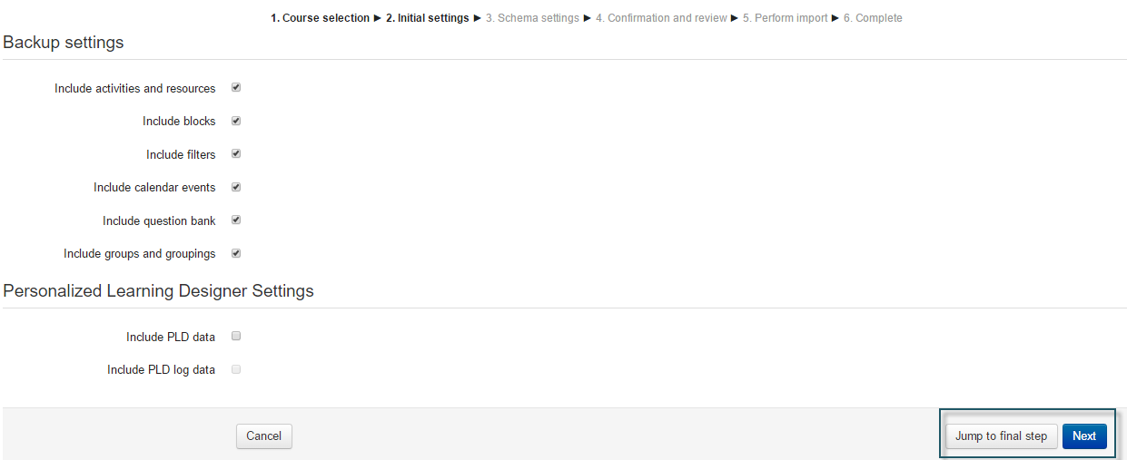
- On the next screen (Schema Settings), again, all items are selected to import by default. Uncheck any items you do not want to import. You can uncheck individual items or entire topics. Any [inaccessible] forums with the blue/green icon should be unchecked and recreated as [accessible] Advanced Forums in the new course. Once you have the items you want selected, click “Next.”
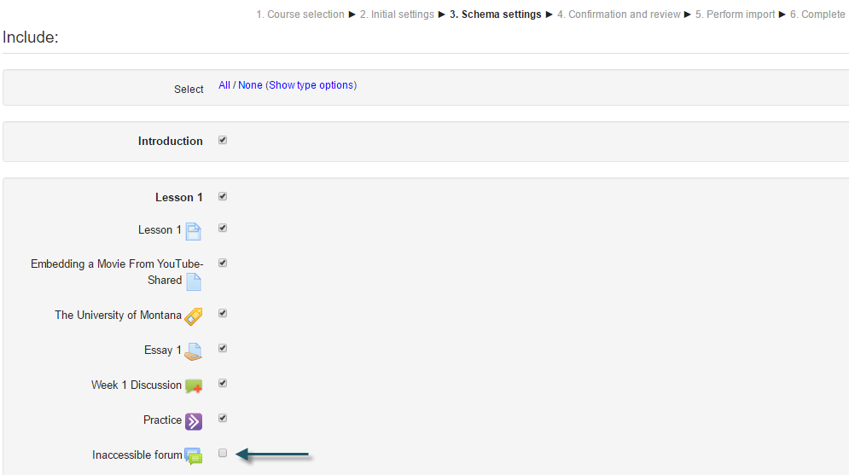

- Review the items selected. If you want to make any changes you can click “Previous” at the bottom of the screen to make adjustments. When you are satisfied with the checked items, confirm by clicking “Perform import.”

- Depending on the amount of content to import, this may take a few minutes to process. You will see a message indicating when the import is complete.

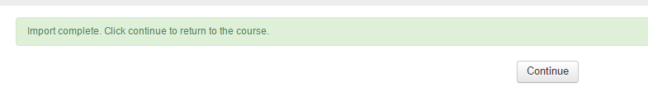

If you need assistance with using this feature, please contact UMOnline Help Desk at 243-4999 or umonline-help@umontana.edu. The Help Desk is open Monday through Friday, 8:00 a.m. to 5:00 p.m.

