How to Backup Your Moodle Course

When you create a backup of a course, you’re essentially creating a file copy of your online content that you can store for future use/reference. Backup files can be restored into a blank Moodle shell. Here are the steps to backup a course:

- Select Backup from the Course administration block if you are using the Clean theme in your course. If you are using the Snap theme layout, the Course administration menu is accessed by clicking the “gear” Admin icon in the upper right corner of your Moodle shell next to your Profile.
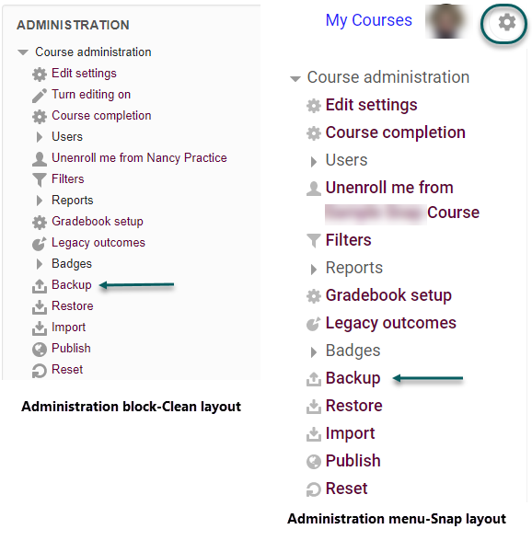
- Uncheck anything in Initial Settings that you don’t need backed up (usually all the default selections are just fine), and click “Next.” If you don’t have anything to uncheck and want everything included in the backup, you can click “Jump to final step” and go to Step 5 below.

- If you chose “Next” rather than “Jump to final step,” uncheck any items in Schema Settings that you don’t need backed up. You can usually just leave most of the items checked, but any old [inaccessible] Forums with the blue and green quotation bubble icon (as shown in the Clean theme below) should be unchecked and recreated as Advanced Forums (accessible) when you restore the course. When you’re done, click “Next.”
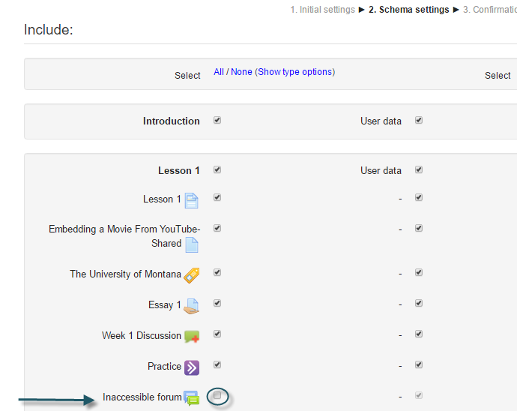

- The next screen is to review and confirm your selections. If you need to change anything use the “Previous” button to go back to make adjustments. Otherwise, just click “Perform backup.”

- Depending on the amount of content, it may take a few minutes to process the backup. You will see a message highlighted in green “The backup file was successfully created” when the backup is completed. You might see a message regarding external file references, which is just a reminder. Click “Continue” to finish.
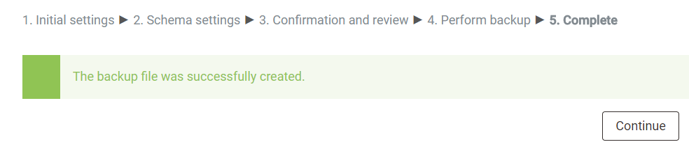
- You will then see your backup file listed in the Course Backup Area. Click the “Download” link of the most recent backup file to download it to your computer’s hard drive. You should delete older backup files as they are not needed. To delete old backup files, click “Manage backup files.” You can then select any unnecessary backup files, keeping only the most recent. In you are in the Clean theme, you can select the “Display File Details” button (see below) to see the last modified date. If you are in Snap theme, you can click a backup file icon and it will display the date it was last modified and then you can choose to delete it.

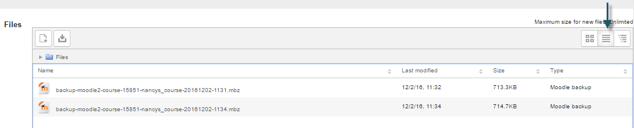

- Click “Save changes” when you are finished. To exit the manage files screen, click the name of your course or the Home or course name link on the bread crumb trail.

If you need assistance with using this Backup feature, please contact UMOnline Help Desk at 243-4999 or umonline-help@umontana.edu. The Help Desk is open Monday through Friday, 8:00 a.m. to 5:00 p.m.

